Sec 3 History Review
Ch. 1 The First occupants

1. Establish a connection between the sedentary lifestyle of the Iroquoians and their subsistence based primarily on agriculture.
Their land was fertile and therefore, the Iroquoians were able to do agriculture. As a result, they were sedentary. There was no need to migrate from one place to another.

2. What connection can you make between the leadership of the chiefs and the decision-making process favoured by Native peoples?
Chiefs were chosen according to their experience and bravery.

3. a) How did Native peoples transmit their culture and knowledge?
Oral Tradition - Storytelling

b) Why did this method of communication play such an important role in Native culture in the early 16th century?
They did not have writing.

4. What two main communication channels were used by Native peoples for trade?
a) By using various waterways (canoes)
b) By walking through forest trails

5. Answer the following questions regarding Jacques Cartier’s voyages.
a) What was Jacques Cartier’s mission during his first voyage in 1534?
To find resources and a route to Asia

b) How did Cartier’s second voyage end?
In a failure. He returned to France.
6. What motivated Native peoples to engage in trade with the Europeans?
They wanted European goods.

7. Explain the impact of trade with the Europeans on Native societies and territory.
It created many alliances and wars. Natives lost their land. They were also converted to Christianity. Many Natives adopted the European way of life.

8. Why did Natives establish systems of alliances?
To trade – To help each other during wars – To make peace with other tribes

9. What supernatural powers did Natives recognize in the shaman?
The shaman was able to communicate with the spirits.

10. Explain the concept of gifts and counter-gifts.
It was important in order to establish alliances and friendships.

11. What is the most popular hypothesis on how the ancestors of Natives reached the Americas?
They came from Asia and travelled through the Strait of Beringia.

12. What were the characteristics of the Inuit’s and Algonquians’ way of life?
Both were nomads – Wigwam and Igloo - Patriarchy

13. Explain Animism.
Every element of nature has a soul.

14. Explain the Circle of life and give an example.
Life is like a circle – It repeats itself – The changing of seasons

Ch. 2 The French Regime

1. Explain the economic role of New France based on the theory of mercantilism.
To provide natural resources (furs) to the mother country.
To enrich the mother country.

2. a) Who was initially mandated by the French King to develop the colony?
The fur trade companies/monopolies.

b) What was their main obligation?
To populate New France

c) What was their main goal?
To profit from the fur trade.

d) What privilege did they obtain from the French state?
They obtained monopolies.

3. Why did the French establish an alliance with the Huron-Wendat Confederacy in the early 17th century?
In order to trade furs.

*4. Indicate one of the Catholic Church’s objectives regarding the colonists of New France and a means used to achieve it.
To provide religious services.

5. In addition to ensuring religious support, what other services did the Church offer the colonists? Education and Health

6. Name two objectives of the Royal Government.
a) To populate New France
b) To stimulate the exploitation of the colony’s resources and to diversify its economy

7. Indicate the role of the Sovereign Council in the colony and name the people who comprised it.
To provide justice. (B.I.G) Bishop – Intendant - Governor

8. Why did Jean Talon try to diversify New France’s economy?
To improve and strengthen the economy of New France.

9. Name one agreement that was reached during the Great Peace of Montreal.
To create peace between the Natives and the French.

10. Name two factors that may have contributed to the birth of a distinct Canadien culture.
a) Influences from the Natives b) Harsh winter climate

11. Name a few of the measures adopted by various intendants to diversify the economy.
They established the Triangular Trade – They built metal factories – They tried cultivating different crops

12. Explain the triangular trade.
The French organized trade between France, New France and West Indies in order to increase France’s wealth by selling manufactured products to its colonies.

13. Name the two main causes of conflict between France and Great Britain in North America in the 18th century.
a) Control of the fur trade b) Control over territory

14. Why does a colony have to participate in wars that involve its mother country?
Because the colony belongs to its mother country

15. What were the consequences of the Treaty of Utrecht for New France?
New France lost a lot of territories

16. What distinguishes the Seven Years’ War from the War of the Conquest?
The Seven Years’ War was in Europe whereas the War of the Conquest occurred in North America.

17. Why were trading posts usually situated near a waterway?
Easier transportation

18. What means did the Church use to evangelize Native people?
They sent out missionaries to learn their language and to live among the Natives.

19. Why did holders of a fur trade monopoly have so little interest in populating the colony?
Because fur trade required few employees.

20. What is the seigneurial system? Give two characteristics.
The French way of organizing the land.
Rectangular and near water

21. Who was usually granted a seigneury?
A French Lord or military officer

22. What is the main explanation for the drop in the Native population of eastern North America in the first half of the 17th century?
Diseases
23. What happened to New France’s territory as a result of the fur trade?
It expanded

24. What government did the king institute in New France in 1663?
Royal Government

25. What structures were designed to protect the colonists?
Forts

26. What did the French state do to establish a demographic balance in New France?
They brought Filles du Roi

27. What measures did the French state take to promote marriages and births in New France?
Financial incentives

28. What key factor contributed to population growth in the colony?
Natural growth/birth

29. Despite diversification measures, why was the economy of New France still based primarily on fur?
Because of mercantilism – Not enough money – Lack of specialized workers

30. In 1681, what did the minister of the marine do to protect the fur trade from overproduction?
He gave out fur trade permits to voyageurs

31. What motivated the territorial expansion of New France in the second half of the 17th century?
The search for furs

32. Indicate two elements that show an adaptation by the Canadiens to the climate of the Vallée du Saint-Laurent.
Acclimatization: They modified their way of dressing (fur coats) and transportation (snow shoes) as well as their house-building techniques.

33. What were the obstacles to economic diversification in New France?
Because of mercantilism – Not enough money – Lack of specialized workers

34. What economic activity was practised by the majority of colonists in New France?
Agriculture

35. How did the Seven Years’ War start in North America?
Clashes in Ohio over the fur trade

36. Give two reasons why the British decided to deport the Acadians.
a) They were afraid that the Acadians would join the French people in Quebec
b) To assimilate the Acadians

37. What is the name given to the battle that resulted in the capitulation of the city of Quebec to the British?
The Battle of the Plains of Abraham

Ch. 3 The British Conquest

1. What type of provisional government did the British introduce in the colony immediately after the Conquest?
The military government

2. Why did the British install a provisional government?
The war in Europe was not over yet

3. Who led the colony under this provisional government?
General Amherst

4. Why did Pontiac revolt?
He was afraid that the British would take their land.

5. Two groups experienced the biggest losses with regard to the territorial changes made under the Quebec Act. Identify them and justify your answer.
The inhabitants of the 13 colonies = They lost the Ohio Valley
The Natives = They also lost many territories – Look at the map

6. Name the two groups who experienced the biggest losses with regard to the territorial changes made under the Treaty of Paris in 1783. Explain each answer.
The French Canadians = They lost the Great Lakes and the Ohio Valley
The Natives = They also lost many territories – Look at the map

7. How did the immigration of the Loyalists to the Province of Quebec affect its population?
The English population increased

8. What event ended the War of the Conquest?
The Treaty of Paris
The end of the war in Europe

9. What was the main mandate of the British military government in Canada?
To control New France until the war ended in Europe

10. Who left New France after the Conquest?
The Governor, Intendant, Bishop and high-ranking military officials

11. What was one of the fears of Natives following the British victory?
That they would lose their land

12. Which element of the political structure provided for in the Royal Proclamation was not established under this constitution?
The National Assembly

13. What demographic fact prompted Governor Murray to be accommodating toward the Canadiens?
There were too many French Canadians

14. How did Carleton justify maintaining the policy of compromise?
Too many French Canadians
There was a huge difference in culture and language

15. What was the goal of Royal Proclamation?
To assimilate the French Canadians

16. What happened to New France’s territory after Royal Proclamation?
It shrank

17. Explain the Test Act.
If one wanted to work for the British government, one had to abandon Catholicism and convert to Protestantism.

18. Which governor played a key role in the adoption of the Quebec Act?
Guy Carleton

19. What religious recognition did the Quebec Act grant to the Canadiens?
The Catholic religion was able to collect tithes. It recognized Catholicism.

20. Which groups reacted negatively to the Quebec Act?
The British merchants

21. What were the causes of unrest in the Thirteen Colonies?
Americans did not want to pay for the war. They did not want to pay higher taxes.

22. What was the goal of Quebec Act?
To please the French Canadians so they would not join the 13 colonies.

23. What happened to New France’s territory after Quebec Act?
It expanded

24. What position did the majority of the Canadien population take in the conflict between Great Britain and the Thirteen Colonies?
They were on the side of Great Britain

25. What Canadien social group began learning English to ensure its economic and social status?
Bourgeoisie or the professional class

26. What were the colony’s main economic activities after the Conquest?
Agriculture, Fur trade, Timber trade

27. What influence did British merchants have over the colony’s economy?
They owned many businesses – They were the main investors

28. What was the primary market for most of the agricultural products?
Domestic market

Ch. 4 The Demands and Struggles of Nationhood

1. The colonists’ demands led to London’s adoption of the Constitutional Act in 1791. What territorial change occurred under this new constitution?
The Province of Quebec was divided into two: Upper and Lower Canada

2. What two political parties were formed in Lower Canada in the early 19th century?
The Parti canadien and the Tory Party

3. In the first half of the 19th century, were the factors that accounted for population growth the same in Lower Canada and Upper Canada? Explain your answer.
No.
Upper Canada = immigration
Lower Canada = natural birth

4. Explain the agricultural crisis experienced in Lower Canada around 1830.
The agricultural lands were no longer fertile – The overproduction of wheat

5. Identify at least two factors that contributed to growing discontent among the Canadiens around 1830.
a) The agricultural crisis of the 1830s (the quantity of wheat dropped in Lower Canada)
b) The use of violence by the British army during political demonstrations
c) The refusal of British authorities to concede new seigneuries

6. How did the Patriote rebellions end?
The British forces crushed the rebellions

7. What happened to the Patriotes involved in these rebellions?
They were arrested and some were hanged
8. With the adoption of the Constitutional Act, what political institutions was composed of members elected by the people?
The legislative assembly

9. What were the three conditions that the inhabitants of Upper and Lower Canada had to fulfil in order to have the right to vote?
a) to be a British subject (men & women)
b) to be 21 years of age or over
c) to be a property owner

10. Why was the governor’s right of veto an important power?
He was able to overrule any law that he didn’t like. He had total power.

11. Name a few of the timber-related trades (jobs) in Lower Canada.
lumber jacks – raftsmen – carpenters

12. Describe what the 92 Resolutions were.
They were 92 demands that the Canadiens wanted from the British authorities.

13. What is the name of the documents that was the British response to the 92 Resolutions?
The Russell Resolutions

14. Among the Canadiens, who opposed the Patriotes’ demands? Who supported them? Why?
Opposed: Catholic clergy, British merchants, British authorities
Supported: The people, French bourgeoisie (Lawyers, doctors, journalists)

Important dates:

1608: Samuel de Champlain and the establishment of Habitation de Quebec

1663: Royal Government

1701: The Great Peace of Montreal

1760: The Conquest and the establishment of the military government

1763: Royal Proclamation

1763: Treaty of Paris

1774: Quebec Act

1791: Constitutional Act

1837-1838: The rebellions

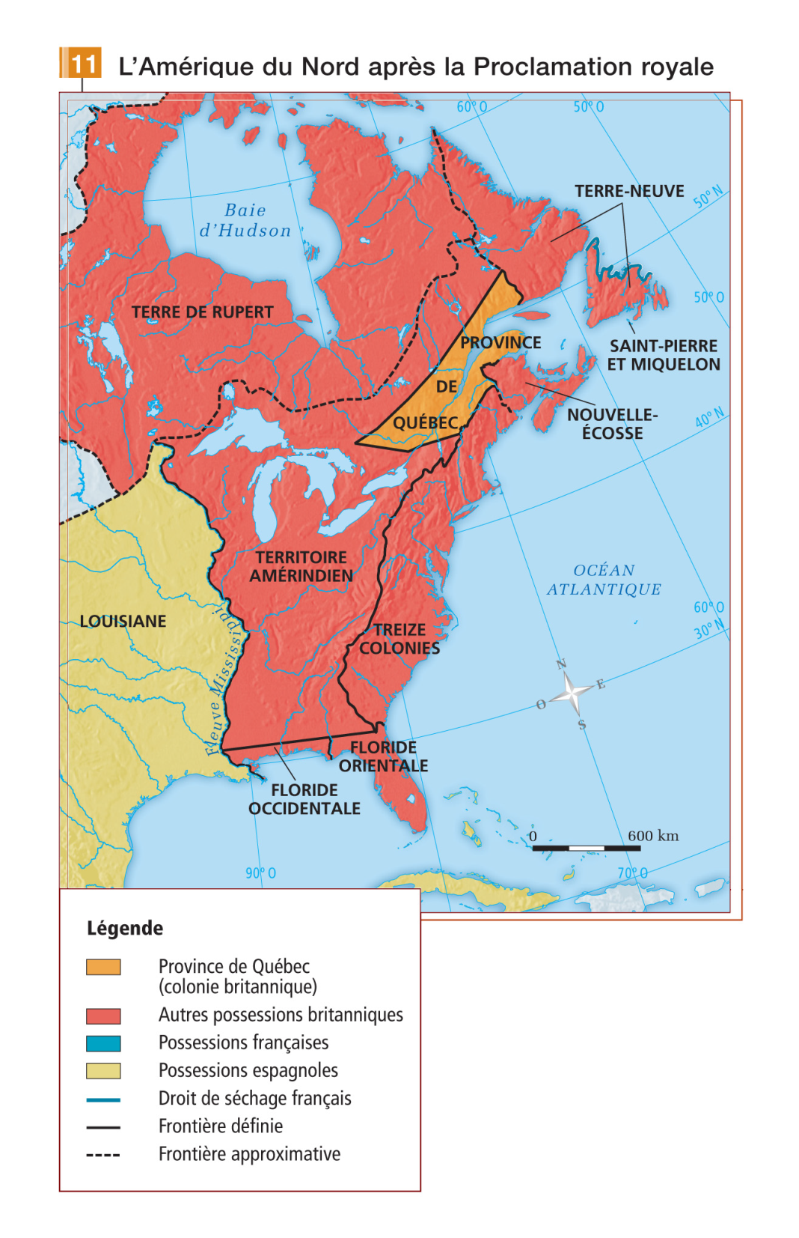

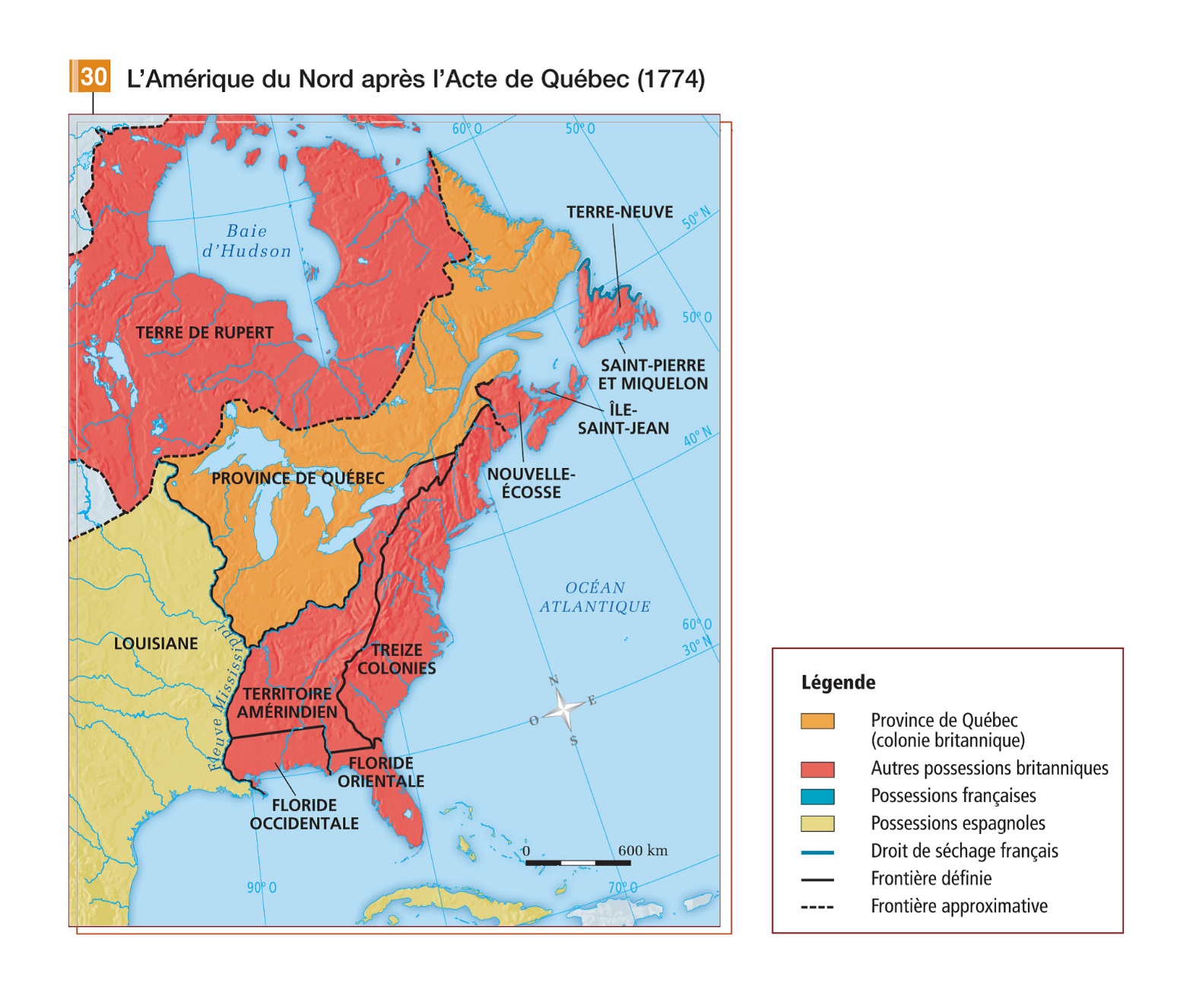

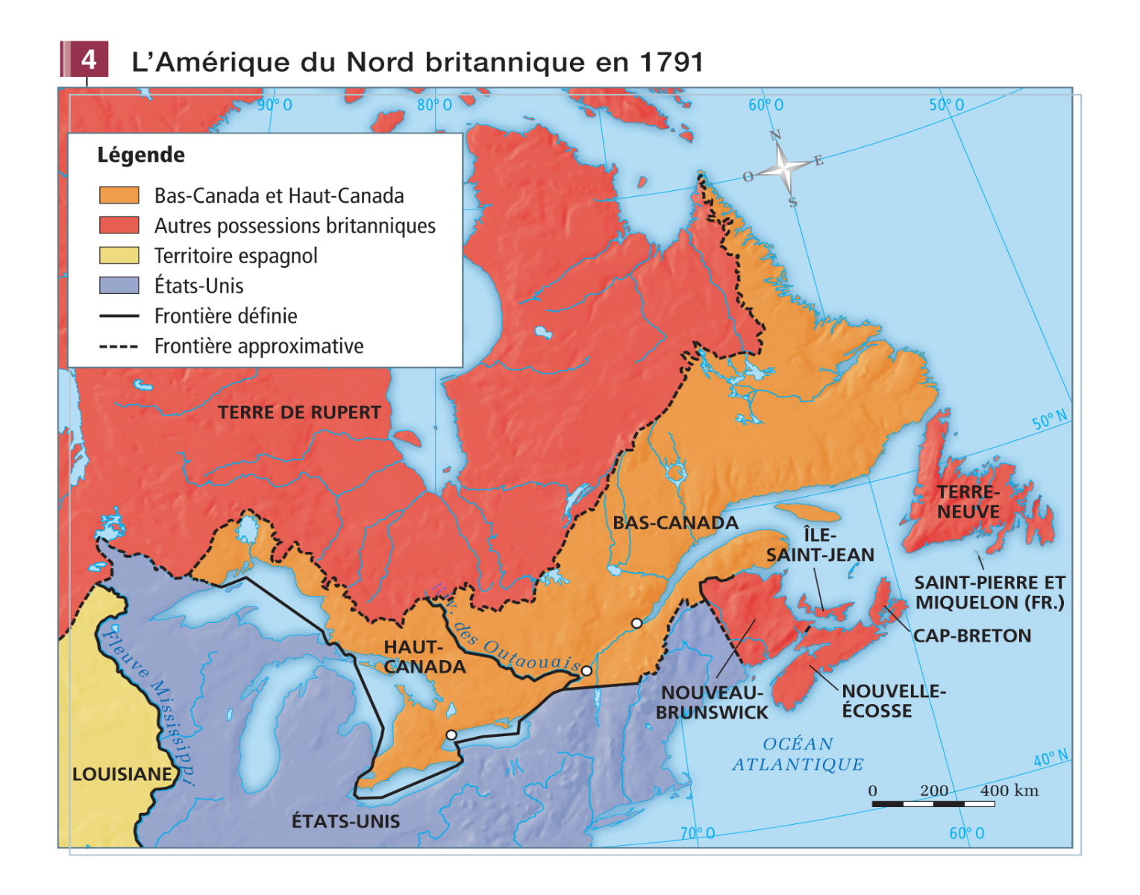

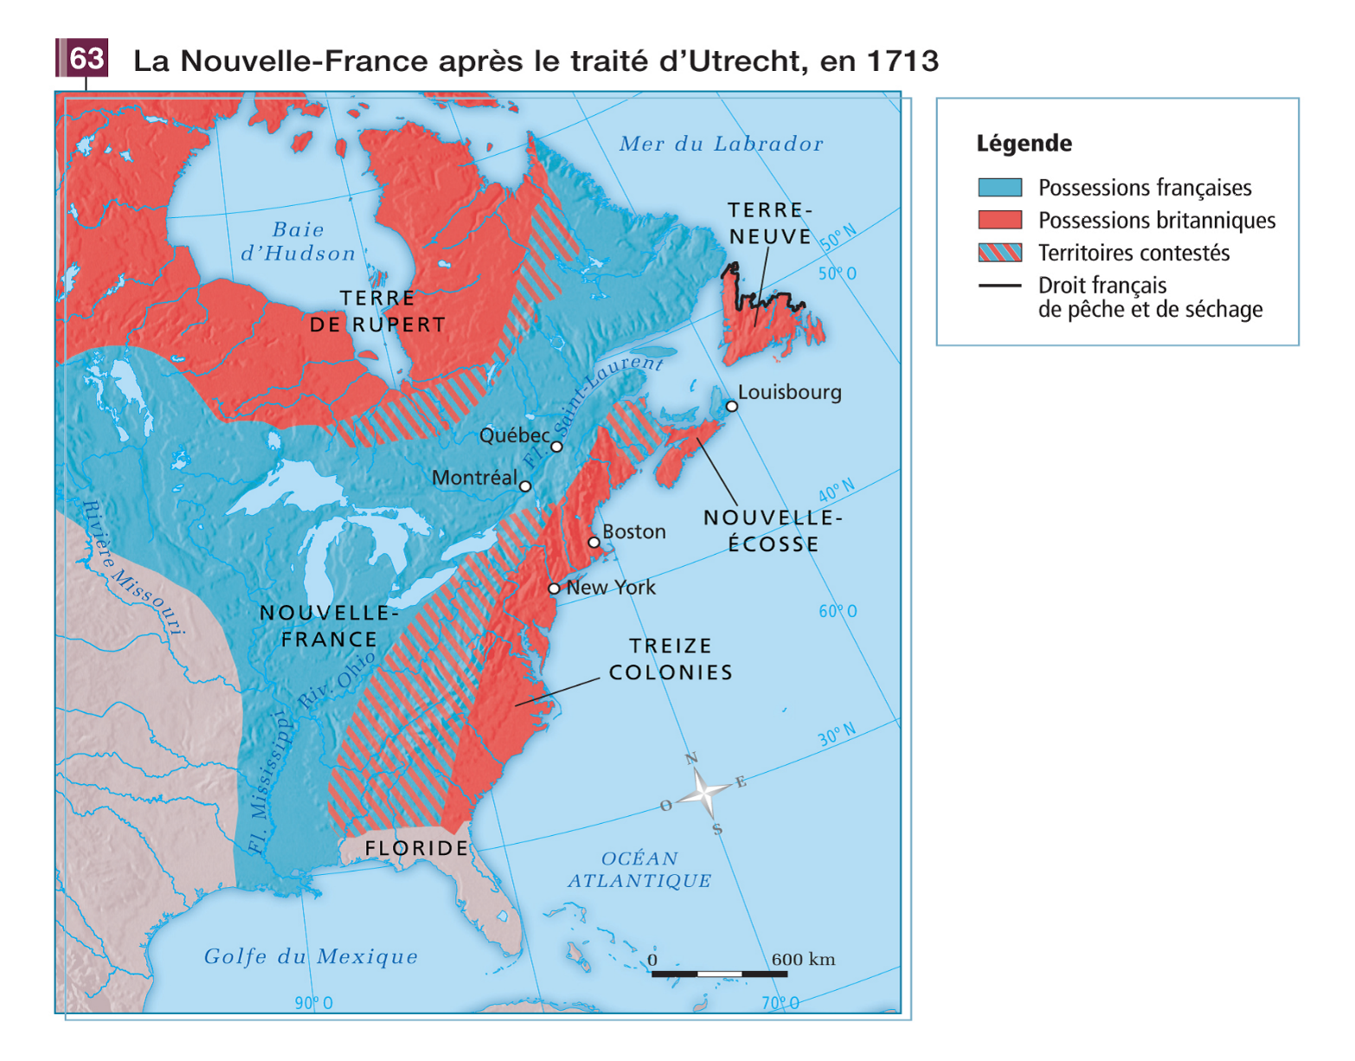

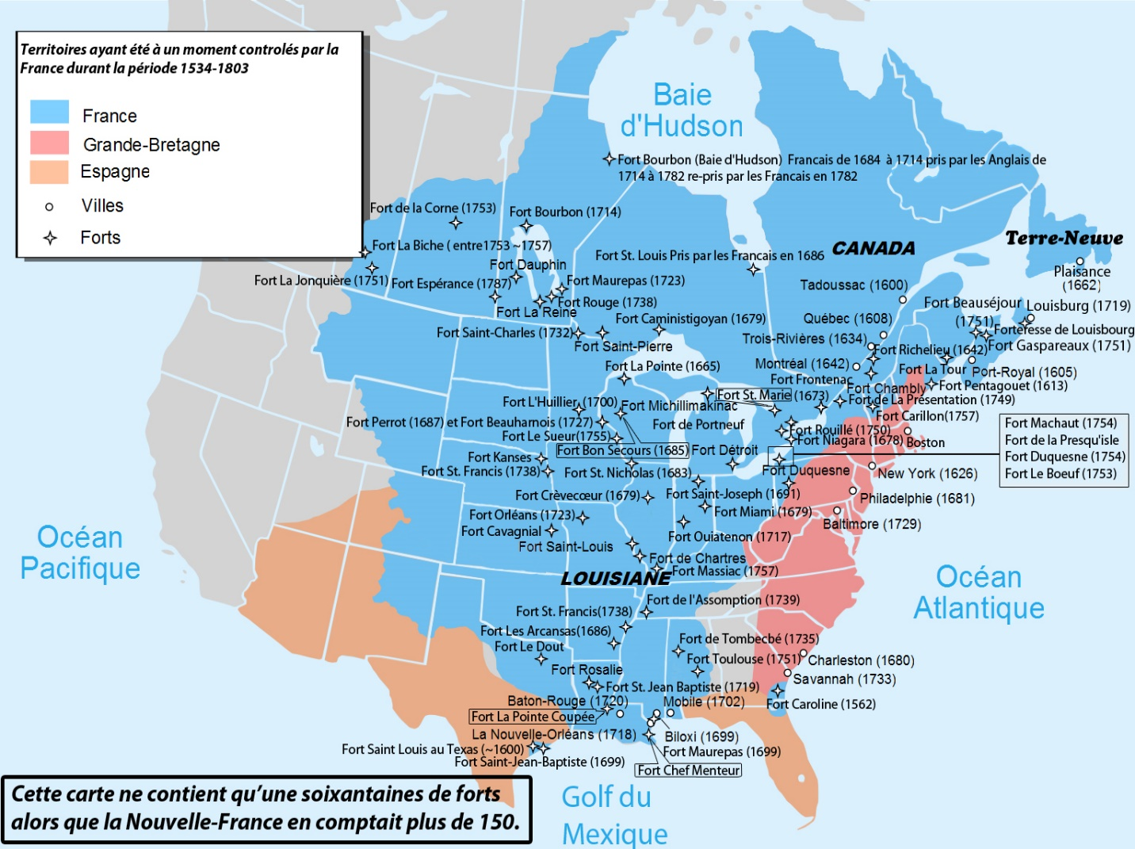

Vocabulary/Big words

Subsistence: Food
Habitants: French farmers
Censitaires: French farmers
Demographics: Population
Domicilié: Aboriginals who lived with the French
Dwelling: House
Palisade: fence
Eloquence: The art of storytelling
Acclimatization: Adapting to climate
Mandate: Order
Assimilation/Acculturation: To adopt someone else’s culture, language & religion
Absolutism: 100% dictatorship
Constitution: A collection of important laws
Conciliatory: Pleasing, flexible, compromising
Embargo or a blockade: No one is allowed to trade

