History Sec 4
Ch. 1 (1840-1896)

1. What political change was introduced by the Act of Union?
-English became the only official language
-Women lost the right to vote in Lower Canada (Canada East)
-Territory: the union of the two Canadas

2. What was the main demand of Reform members of the Legislative Assembly in 1841?
-Responsible Government

3. What economic system replaced the United Kingdom’s protectionist policy in 1846?
-Free Trade

4. What was the consequence of this change in economic policy?
-Less exports towards Great Britain
-More exports towards the United States
-The loss of employment in certain sectors

5. What situation resulted in ministerial instability in the Province of Canada between 1854 and 1864?
-Between 1854 and 1864 (10 years), more than 10 minority governments succeeded each other in the Province of Canada.

6. What were the main factors driving the first phase of industrialization in Canada?
a) Cheap labor: immigrants
b) Investment capital ($): Great Britain
c) A good transportation system: the railway and canals

7. What were the demands of trade union associations that emerged in the second half of the 19th century?
-Better working conditions

8. What ideology advocated that the pope’s authority was absolute and that believers, like states, had to submit to it?
-Ultramontanism

9. What movement of thought affirmed that the clergy did not have the right to interfere in political life, to censor cultural productions or to control the intellectual life of the population?
-Anticlericalism

10. What were the three main demands of feminists in the second half of the 19th century?
a) Access to higher education
b) Voting rights
c) Legal rights

11. What was the objective of the Métis in creating the National Committee of Métis?
-To protect their territory
-To negotiate with the Canadian government

12. Name the three components of the Macdonald government's National Policy.
1) Increase tariffs (taxes) in order to protect the Canadian industry.
2) Expand the railway network in order to populate western Canada.
3) Increase immigration in order to develop the internal market.

13. What were the two main causes of tension between the federal government and the provinces at the end of the 19th century?
-The sharing of powers
-The sharing of tax revenue (taxes)

14. What did Quebec claim particularly?
-Provincial autonomy: to guarantee their rights and to protect the French language

15. What was the common political objective of the English Canadian and French-Canadian Reformers?
-To achieve responsible government

16. Who were the leaders of the Reform coalition in 1841?
-Baldwin and Lafontaine

17. In the 1860s, what region was coveted by both the Province of Canada and the United States?
-Western Canada

18. What was the consequence for the Province of Canada of the end of the Reciprocity Treaty with the United States?
-Canada had to increase trade with other British colonies in North America.

19. What political alliance in the Province of Canada was at the origin of the Confederation project?
-The Great Coalition

20. What is the BNA Act?
-British North America Act
-Objective: This Act finalized the union of the British colonies in North America.

21. What four provinces formed the Dominion of Canada in 1867?
-Quebec -Ontario -Nova Scotia -New Brunswick

22. How were the powers distributed within the Dominion of Canada?
-There is one federal government and four provincial governments

23. What manufacturing sectors developed during the first phase of industrialization?
a) shoes b) textiles c) tobacco

24. What economic system favored industrialization?
-Capitalism and Free Trade

25. What social class emerged with industrialization?
-Working class

26. Why were employers interested in hiring women and children?
-They are easier to control
-So they could pay them very low wages

27. How did industrialization lead to urbanization?
-A lot of people moved to urban areas (cities) in order to find jobs

28. How did the Quebec government and the Catholic clergy attempt to curb the emigration of French Canadians to the United States?
-By giving them farmland in remote areas

29. What school of thought favoured the rise in the Church’s influence after 1840?
-Ultramontanism

30. What were the characteristics of French-Canadian identity according to the nationalism of survival?
a) French culture and language
b) The Catholic faith
c) A traditional way of life (agriculture)

31. What values ​​advocated by the Institut Canadien opposed ultramontanism and displeased the Catholic Church?
-Tolerance and freedom of thought

32. What is patriotic literature?
-Patriotic literature reflects the main characteristics of the French-Canadian identity.

33. Which three provinces joined the Canadian federation in the early 1870s?
a) Manitoba
b) British Columbia
c) Prince Edward Island

34. In what regions did the Métis uprisings occur?
-In western Canada

35. What was the main purpose of the Indian Act?
-Assimilation

36. What measure did the Macdonald government adopt to counter competition from US companies?
-The Macdonald government increased customs duties (taxes)

37. What was the economic objective behind the construction of the transcontinental railroad?
-It increased the numbers of consumers and developed the internal market

Ch. 2 (1896-1945)
1. What were the effects of the Laurier government's immigration policy on the organization of Canadian territory?
-The settlement of the West

2. What factors favoured the development of Abitibi at the beginning of the 20th century?
-The granting of agricultural lands in order to encourage the Canadiens to stay in Quebec instead of going to the United States.

3. Explain how residential schools were used to implement the Canadian government’s policy of assimilation of Aboriginals toward the end of the 19th century.
-Indigenous youth had to learn French or English
-They had to convert to Christianity

4. Which three types of infrastructure associated with the transportation of resources benefited from trade development in the early 20th century?
-Canals
-Railways
-Roads

5. Describe the context that led to the creation of Goutte de lait clinics.
-There was a high mortality rate in children due to unpasteurized milk

6. What was the consequence for Canada of not having obtained full legal autonomy by the Statute of Westminster?
-Canada could not change the Constitution

7. Name four elements associated with the intensification of mass culture in the 1920s?
-A) Radio B) Cinema C) Cabarets D) Professional Sports

8. Explain how unemployment maintained the vicious cycle of the Great Depression.
-Lack of jobs will lead to fewer consumers. As a result, many companies will go bankrupt.

9. What does Keynesianism propose in relation to the effects of capitalism, especially those of the Great Depression?
-A better distribution of wealth (collection of taxes)

10. What was Maurice Duplessis's opinion on unions?
-They are bad and not good for the economy

11. Name the program established by the Quebec government to counter the effects of the Great Depression that reflected the solution advocated by the supporters of clerico-nationalism.
-The government proposed agricultural colonization (rural life)

12. What right, established at the federal level in 1918, was granted to Quebec women in 1940?
-The right to vote

13. How did the imperialists' attachment to the British Empire manifest itself?
-The British merchants took control of the economy. (fur trade, wood industry, banks)
-English became the official language.
-The creation of English schools (McGill University), Protestant churches and townships.

14. Which two provinces were created in 1905?
-Alberta
-Saskatchewan

15. Why did the Quebec government open up Abitibi to colonization in 1910?
-To reduce poverty
-To stop the emigration of Quebecers to the United States

16. Name regions that developed through the exploitation of natural resources.
-Côte-Nord -Abitibi and Gaspésie

17. Which foreign country invested the most in Quebec and Canada?
-United States

18. What objective do businesses pursue in a capitalist system?
-To maximize their profit

19. What were the unions' demands concerning the working conditions of the workers?
-The reduction of the number of working hours
-The prohibition of child labour

20. What measures were put in place in order to improve hygiene in urban areas?
-Vaccination campaigns
-The government set up water and sewer networks

21. What was one of the most important shortcomings of the Quebec school system?
-The low level of education of Francophones compared to Anglophones. There were not many Francophones who went to school.

22. What act passed by the federal government allowed it to take all the necessary decisions regarding the war effort?
-War Measures Act

23. What was the consequence of the First World War for immigration to Canada?
-Canada closed its doors to several Europeans

24. Identify two measures taken by the federal government to finance the war effort.
-The government sold Victory Bonds
-The government imposed taxes on income

25. What did Canadian industries do to meet their labour needs?
-They started to hire women

26. Why was there a conscription crisis in Canada?
-French Canadians saw this war as an imperialist war.

27. Why did the Great Depression have a significant impact on Canadian exports?
-American industries no longer had money to buy Canadian products. Therefore, Canadian exports to the U.S. declined rapidly.

28. What resources were offered to the unemployed in 1929?
a) The introduction of public works (roads, bridges, highways, etc.)
b) The government established direct relief programs (welfare, soup kitchens)
c) The government proposed agricultural colonization in order to reduce the unemployment rate

29. What did the Catholic clergy and French-Canadian nationalists offer as a solution to counter the effects of the Great Depression?
-Agricultural colonization and the promotion of farmlands

30. According to Maurice Duplessis, what was the backbone of Quebec’s economy?
-Agriculture and the rural life

31. What was the Union nationale’s relationship with unions?
-A negative relationship. The Union nationale did not like unions.

32. What distinguished the French-Canadian nationalism of Henri Bourassa from the clerico-nationalism of Lionel Groulx in terms of a sense of belonging?
-Henri Bourassa wanted Quebec to be part of Canada while Lionel Groulx wanted to promote Quebec only.

33. What immigration policy did Canada adopt during the Second World War?
-Canada closed its doors to several European countries

34. What was the result of the 1942 conscription plebiscite?
-The majority of Canadians said yes to conscription

35. What labour force did industries turn to in order to meet their needs?
-They decided to hire women

Important dates
1840: Act of Union

1850-1896: First phase of industrialization

1848: Responsible Government

1854: Treaty of Reciprocity

1867: The British North America Act (Quebec, Ontario, Nova Scotia, New Brunswick)
1870: (Manitoba) 1871: (British Colombia) 1873: (PEI)
1905: (Alberta, Saskatchewan) 1949: (Newfoundland)

1900-1929: Second phase of industrialization

1931: Statute of Westminster

1918 and 1940: The right to vote for women

Important concepts/events

-Act of Union
-Responsible government
-Ministerial instability & the Great Coalition
-BNA Act
-Emigration of French Canadians to the USA
-Ultramontanism, Survival nationalism, Anticlericalism, British Imperialism,
French-Canadian nationalism, Social Conservatism, Economic Liberalism, Secularism,
Americanism, Neoliberalism
-The first & the second phases of industrialization
-The Reciprocity Treaty
-The economic crisis of 1870s
-The National Policy
-The Métis uprising
-Indian residential school system
-Mass culture
-WWI & WWII
-The conscription crisis
-The Great Depression

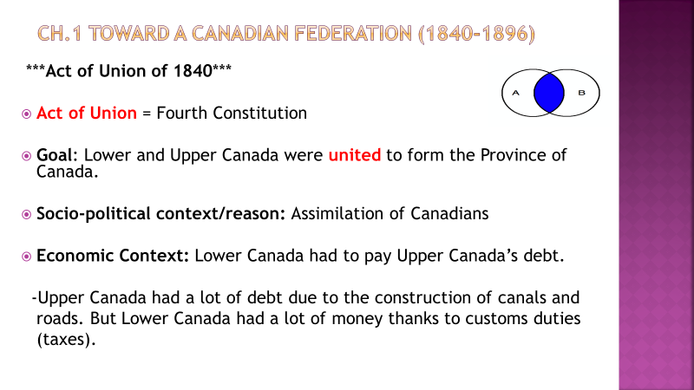

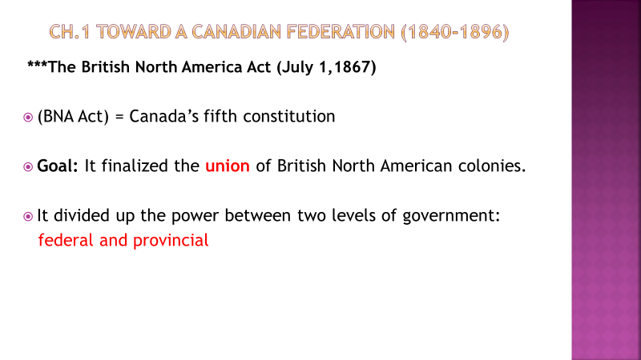

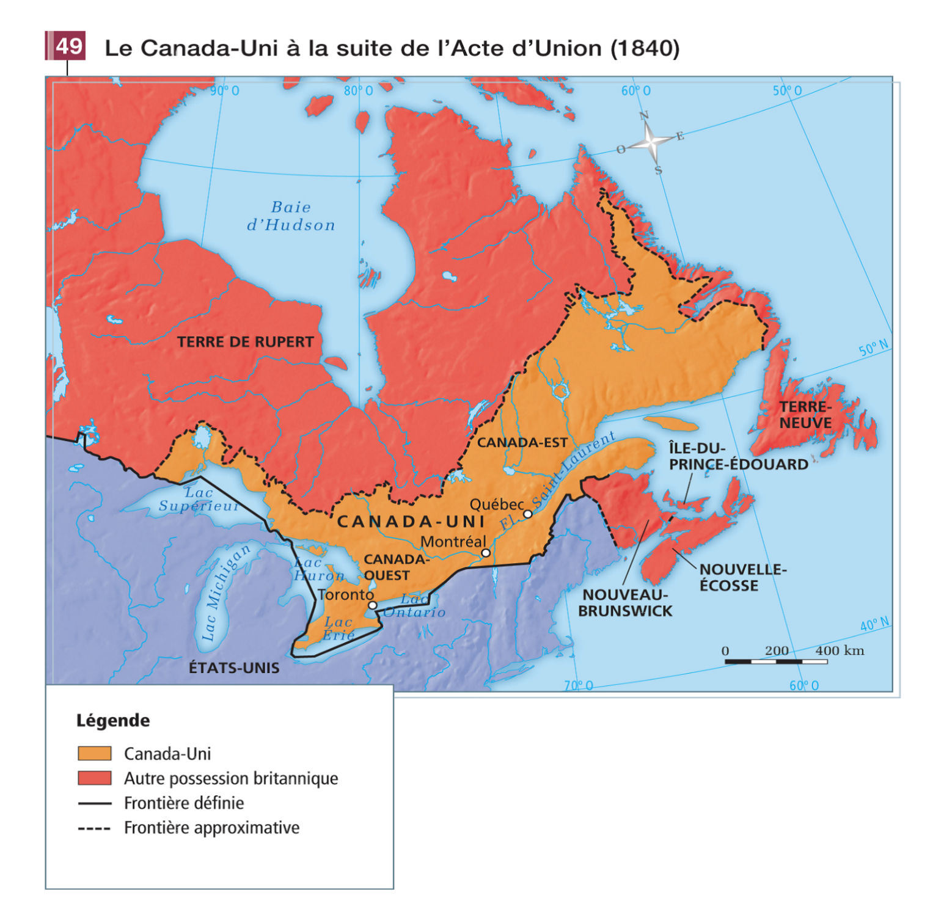

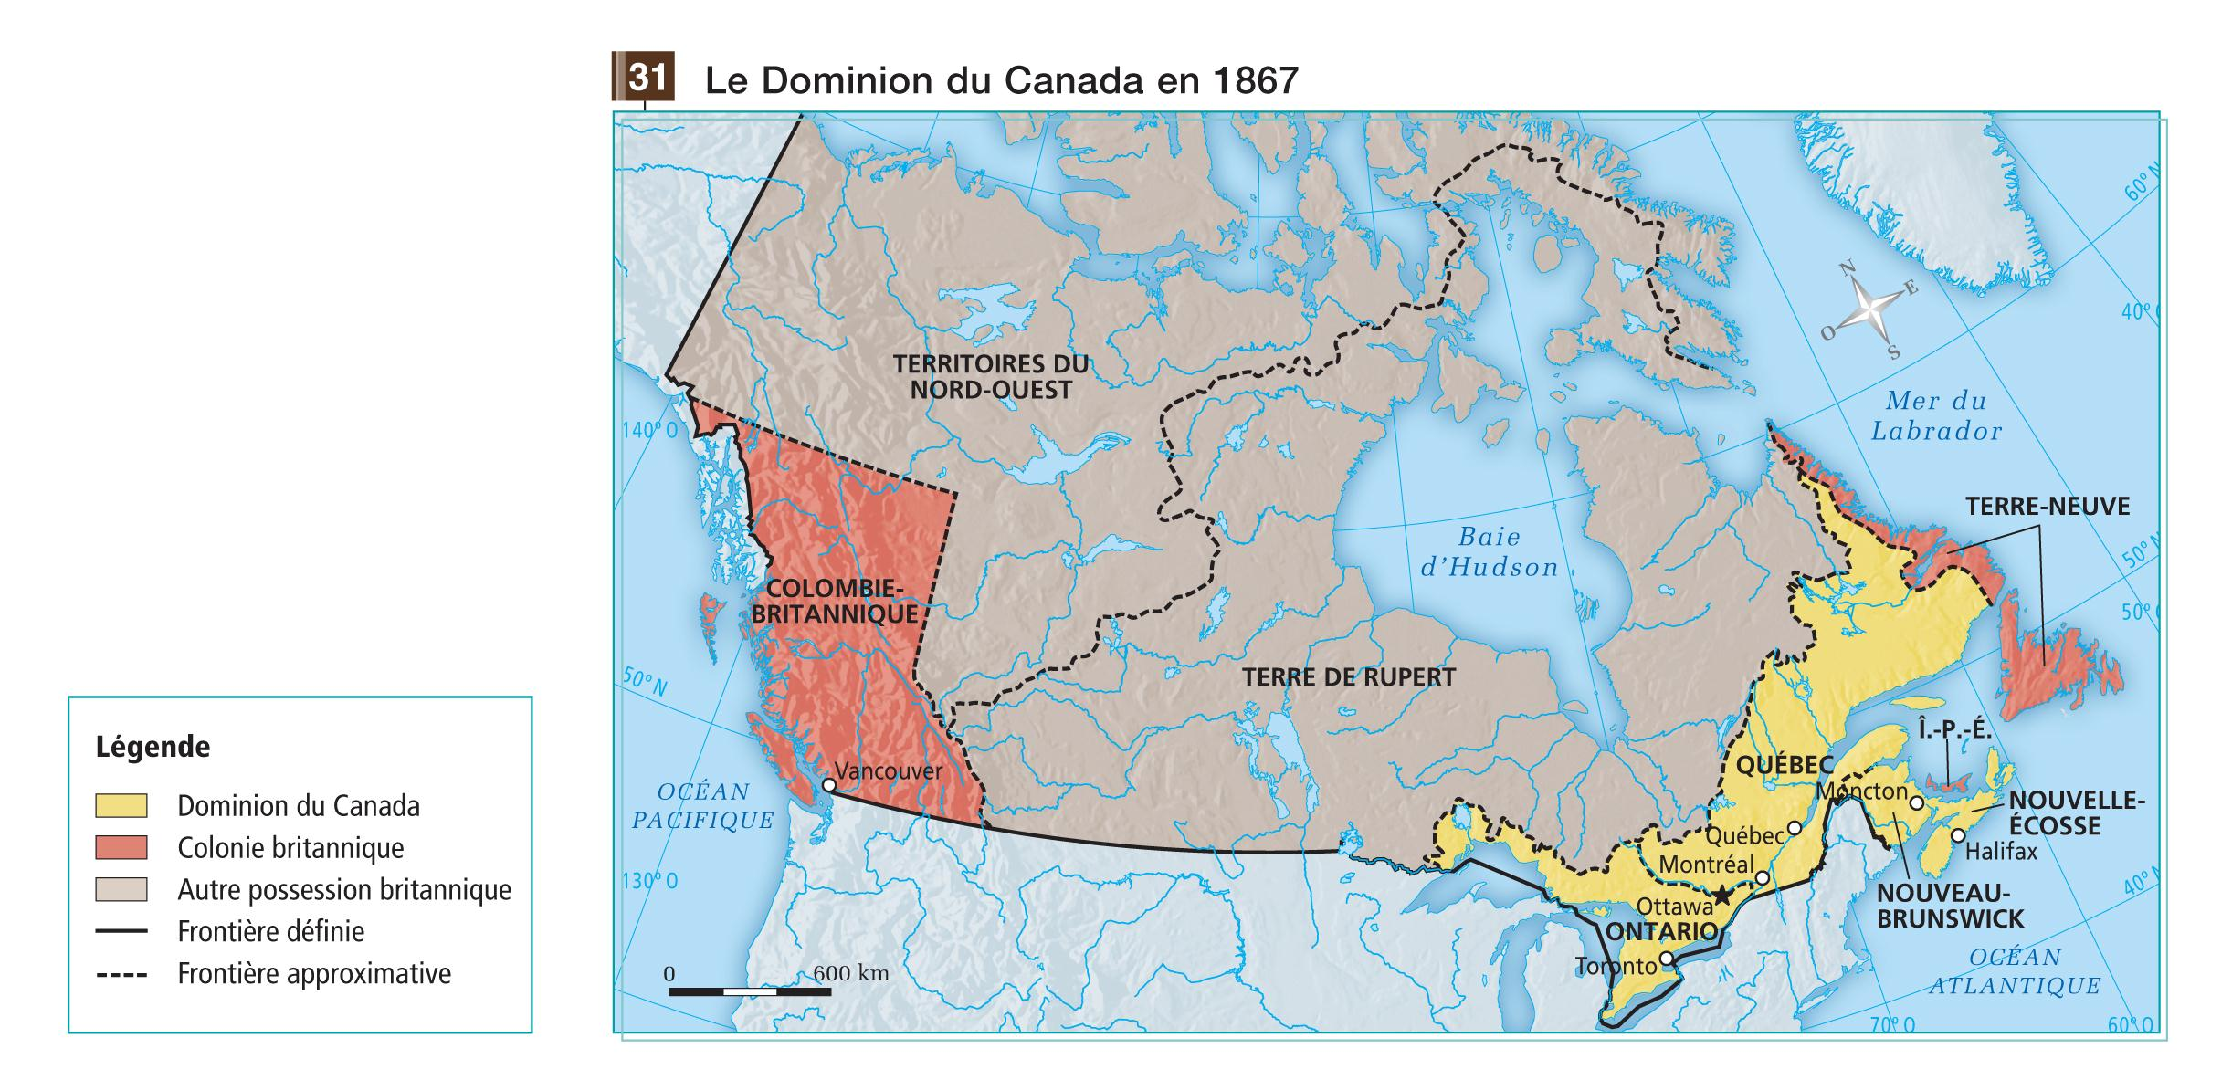

Vocabulary/Big words

Demographics: Population
Ultramontanism: The Catholic Church is above everyone else
Survival nationalism: The Catholic Church wanted to safeguard its importance
Anticlericalism: They supported the separation of Church and state
Denominational schools: Schools based on their religion
Imperialism: The king and his governors wanted to expand the British Empire.
(Robert Borden 1911-1920 - WWI)
French-Canadian nationalism: Attachment to the French language & culture
(Honoré Mercier 1872, Henri-Bourassa 1896)
Clerico-nationalism: It is based on the family, the Catholic religion, the rural way of life.
(Lionel Groulx)
Xenophobia: Hatred of others
Ration: To limit the consumption of a product
Plebiscite: Vote (opinion) of the population on a subject

